# Task 1 – Linux Basics

1. Obtain and install VMWare Player.

* VMWare Player is a virtualization tool – a “software implementation of a machine (i.e a computer) that executes instructions like a physical machine.” It emulates many facets of a physical computer; including various external peripherals, processing units, network devices etc.

A virtual machine is commonly used in situations where two environments must coexist, in strong isolation from each other. It provides a high level of abstraction, and security.

VMWare Player can be found at <http://www.vmware.com/products/player>

1. Obtain required VMWare Player files and the intended operating systems installation disk. These can be created by hand in a text editor, or a precreated file can be downloaded from <http://www.easyvmx.com>

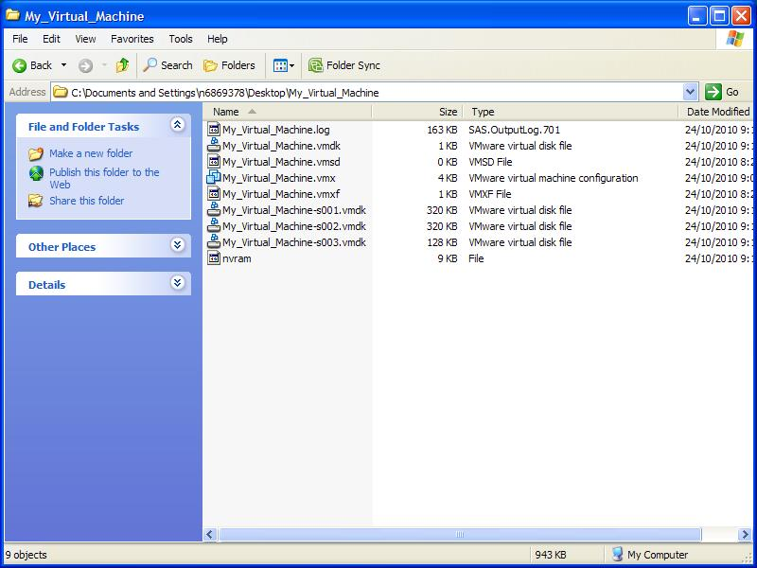

VMWare player uses several setup files to provide its emulation:

* The *.vmx file is a simple ASCII encoded text file responsible for describing the low-level system architecture. This includes hardware descriptions (memory sizes, number of CPU’s), instruction set capabilities, and kernel level capabilities. It also contains various other information, like the relationship between the host computer and the virtual machine. It contains minimal information about the intended use of the machine – what OS it will be running.
* VMWare Player also uses several *.vmdk files. These files contain the virtual machines partition contents, layout and storage scheme. As the virtual machines disk contents grows, these files also grow. The number appended to the suffix of the filename indicates the disk chunk. For example if you specify a 20GB drive, and your *.vmdk chunk size is 2GB, you would have 10 *.vmdk files, labeled 001 to 010.
* The operating system installation files are simple disk images commonly available in various formats (*.iso, *.nrg, *.bin) and are intended to be mounted to VMWare Players virtualized CDROM drive. Once mounted, the disk image acts just like a real CDROM disk and the disks contents are read.

The files should be extracted into a folder located somewhere convenient.

1. Edit the *.vmx file obtained in the previous step. Change the line beginning with “displayname” to correspond with the intended name for the virtual machine – in this case my first and last name concatenated: DominicBousamra .
2. Start VMWare Player, click “Open” and browse for the recently created/downloaded *.vmx file. Wait for the virtual machine to load.

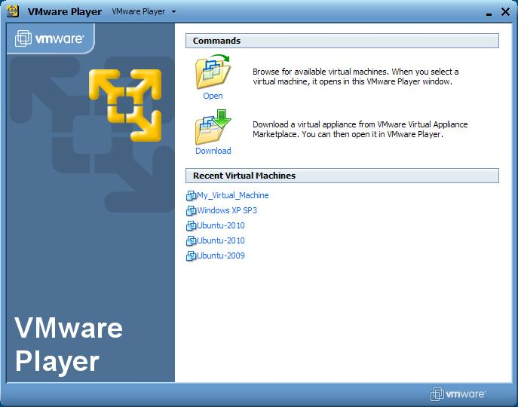

* VMWare player will stall, erroring with a message like “Operating system boot sector now found”. This is because VMWare Player has only been given a raw computer to work with. The virtual hard-disk contains no operating system.

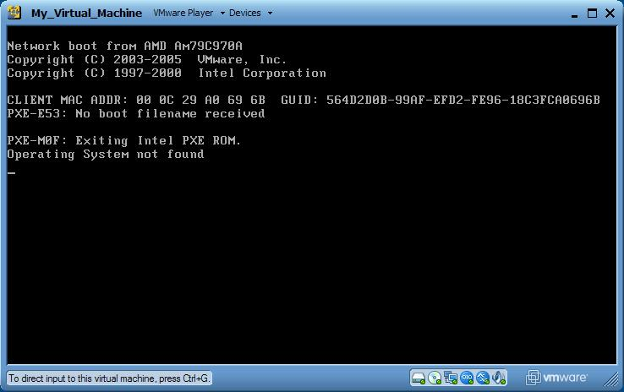

1. Right-click the CDROM icon and click Disconnect. Right click it again, and click Load from image. Browse to the Operating System disk image intended to be installed (Ubuntu in this case). Click OK, and reset VMWare Player; the operating system installation procedure should begin.

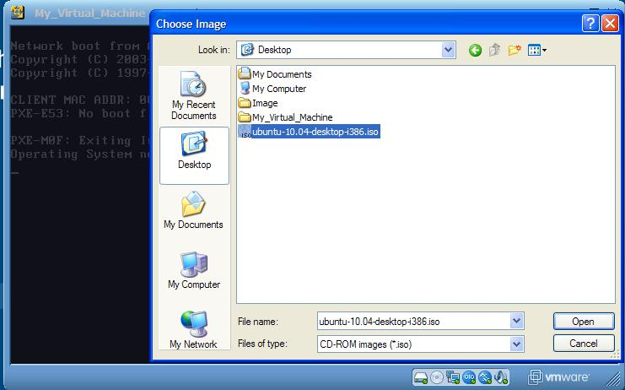

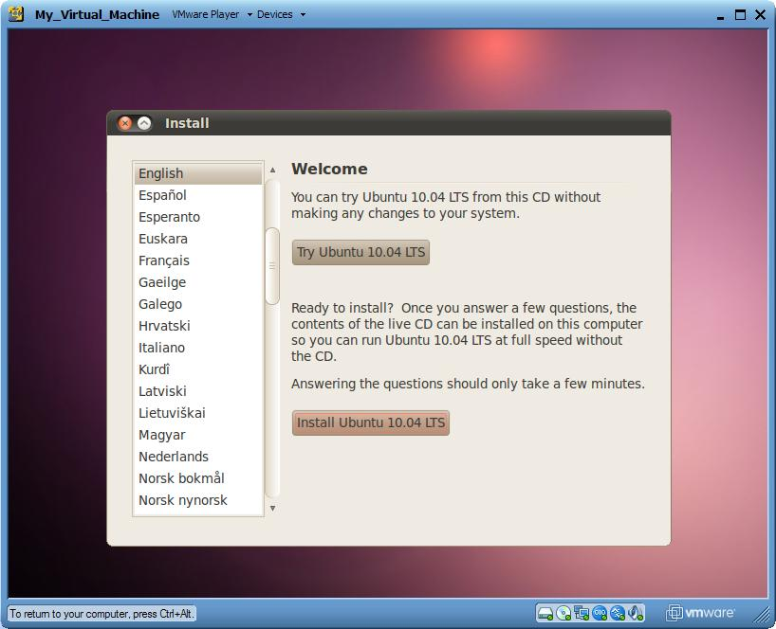

1. Navigate though the prompts in the installation procedure until a screen appears asking for your name and password. Under the “What name do you want to use to log in?” enter your first name (dominic). Under the “What is the name of this computer?” use your concatenated first and last name (DominicBousamra). Continue through the installation procedures prompts

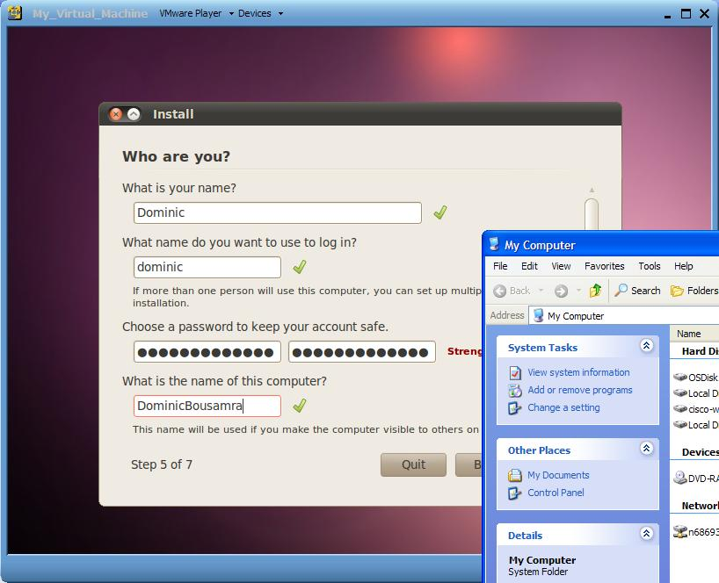.

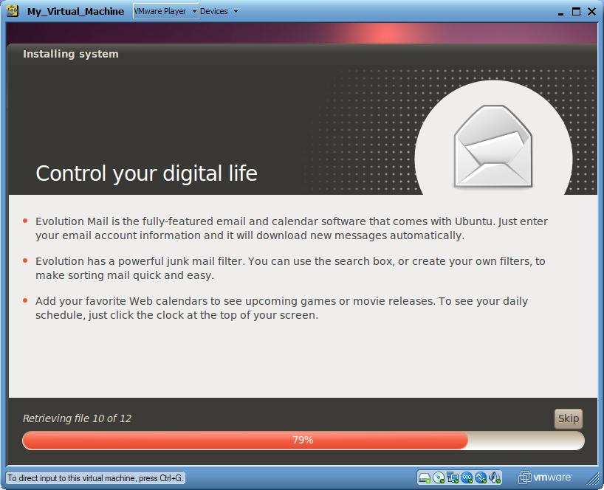

1. Once the installation has completed, disconnect the Ubuntu *.iso from the virtual machines CDROM drive. Restart the virtual machine.
2. Once the virtual machine has restarted you will be asked to login. Login.
3. You will be presented with the desktop. Navigate to the Home folder using the Places toolbar at the top of the screen. Create a new directory in the form “YYYY-MM-DD” using your date of birth (1990-01-22).

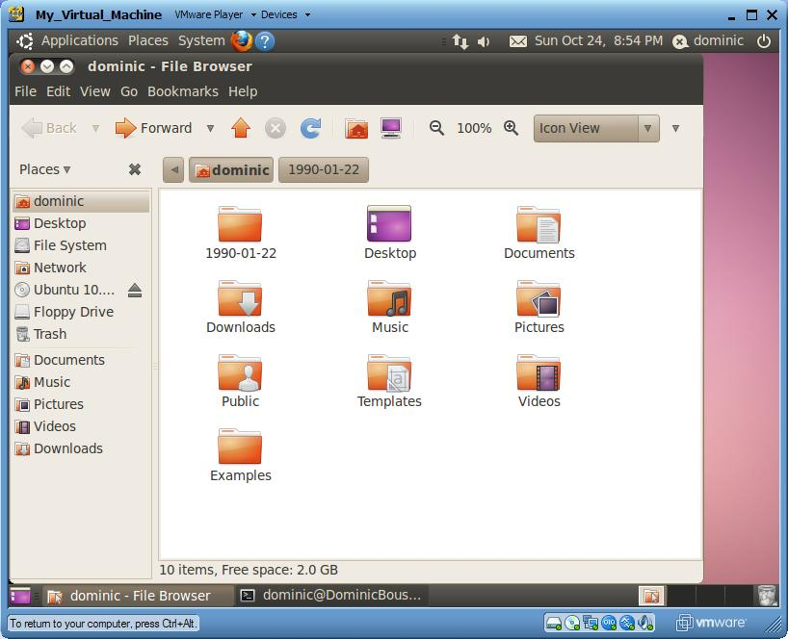

1. Create a new file with the extension *.sh named BirthdayCheck in the Home folder. This is the script file. Open it in a text editor of your choice. The echo command will be used, and the redirection operator used to write to a file.

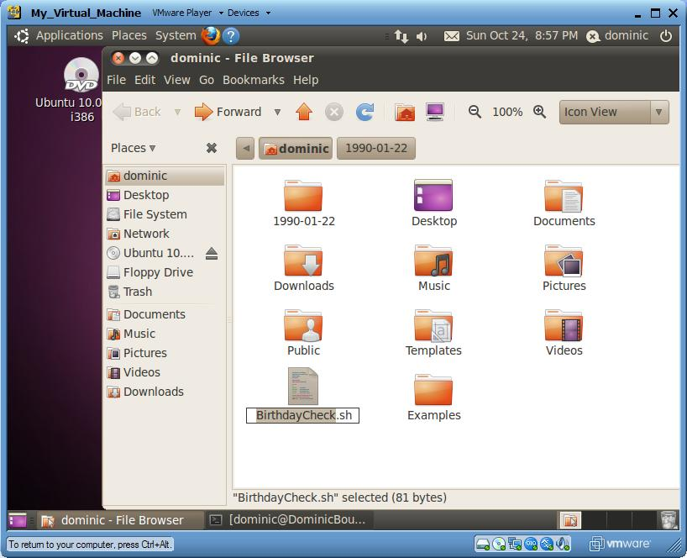

* 1. Add the sh identifier to the beginning of the file: “#!/bin/sh”. This tells the system what language you are dealing with.
     1. #!/bin/sh
  2. On the next two line, add your name and date of birth respectively preceded by a hash symbol (#):
     1. #Name: Dominic Bou-Samra
     2. #DOB: 22-01-1990
  3. Use the echo command to print the current date and time to the file birthday.log located in the folder we created in the above step. The >> symbol indicates we are writing to a file. Using just one > indicated we would like to overwrite the file everytime the script is run. Using a second > operator (>>) indicates we would like to append to the file if it exists:
     1. echo `date` >> 1990-01-22/birthday.log

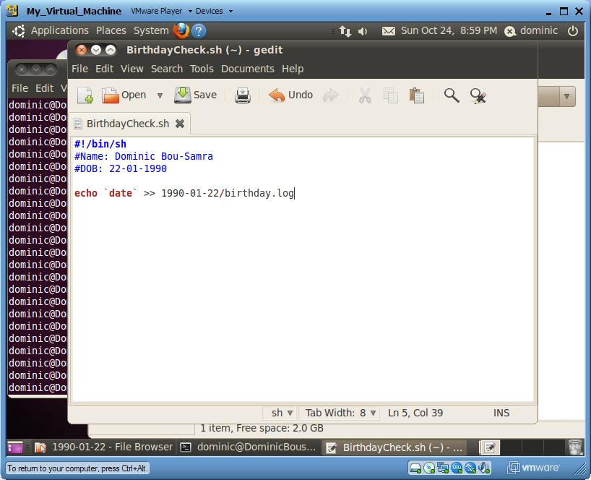

1. To execute the script, navigate to the folder containing the script using the shell window, and execute the command “sh BirthdayCheck.sh”. Open the birthday.log file to confirm the file was written correctly

. 